Pulse-Width Modulation using the MSP430 Timer Module

The built-in timer module on the MSP430 is handy for many applications. In particular, the timer module can be used to implement the following four functions:

1) Pulse counting – useful for counting internal or external events, taking frequency measurements

2) Input capture – for time-stamping external events and taking time-interval or period measurements

3) Output compare – for generating time delays, time-base signals, various frequency signals

4) PWM – generating pulse-width modulation and arbitrary analog and digital waveforms

Here we will focus on PWM digital waveforms.

Select I/O pin to use

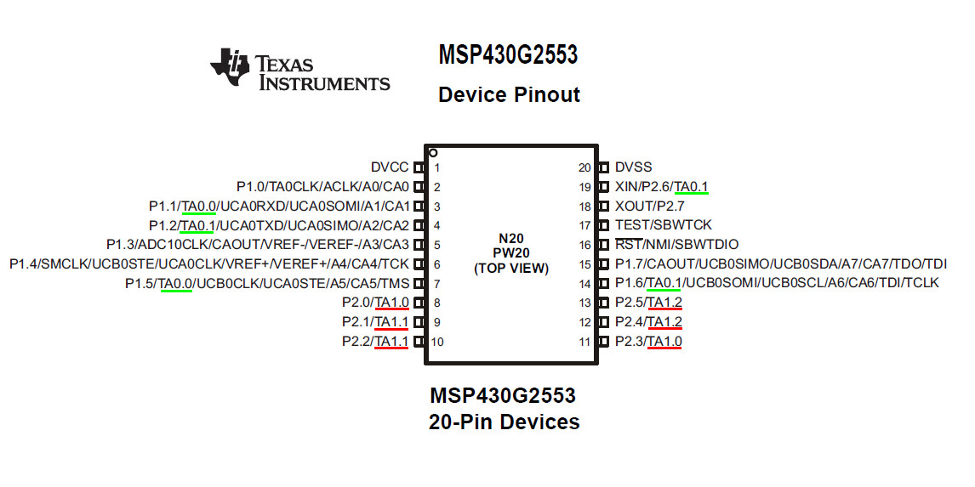

2017.03.08

The IC pinout shows which pins can be used for the different timer outputs.

TA0.0 is available on P1.1 or P1.5
TA0.1 is available on P1.2 or P1.6 or P2.6

TA1.0 is available on P2.0 or P2.3
TA1.1 is available on P2.1 or P2.2
TA1.2 is available on P2.4 or P2.5

In this example, we will be using TIMER1, OUT1 and will use TA1.1 on P2.1.
Hence we will connect pin-9 to the “primary peripheral module function” which is TIMER1, OUT1.

C code:

P2SEL2_bit.P1 = 0;
P2SEL_bit.P1 = 1;

Select the Timer Mode

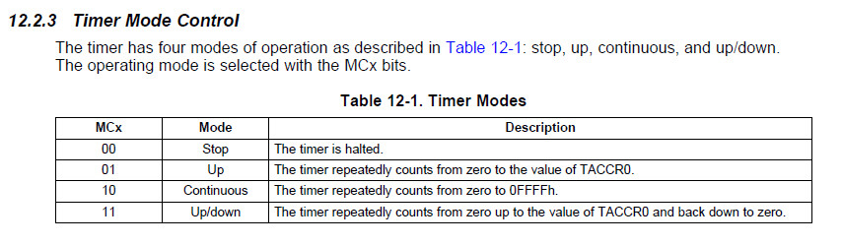

Select Continuous Mode, i.e. count from 0 to 65535 repeatedly.

C code:

// select SMCLK, divide by 1, continuous mode
TA1CTL = TASSEL_2 + ID_0 + MC_2;

Select the Output Mode

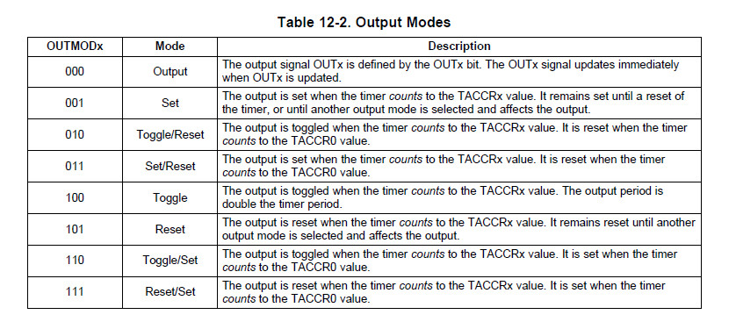

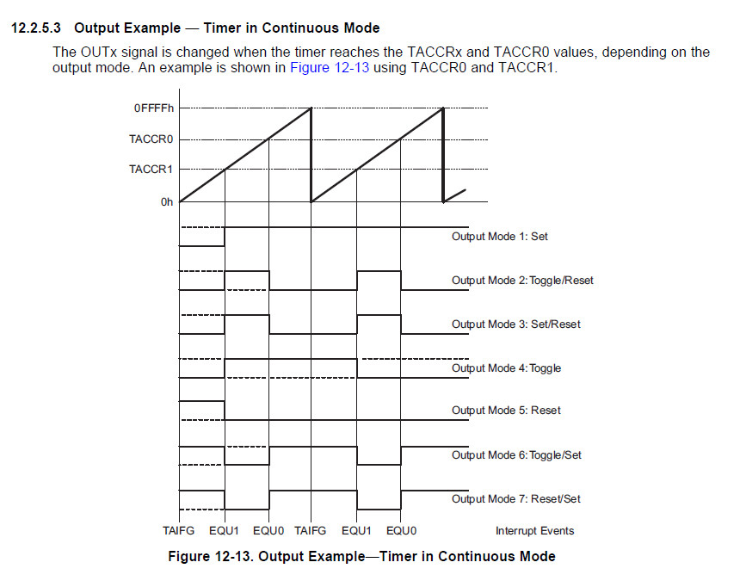

Select Output Mode 3: Set/Reset

C code:

TA1CCTL1 = OUTMOD_3;

TA1CCR1 = 0;
TA1CCR0 = 25000; // pulse width is 25ms with 1MHz clock

When the TA1R register matches TA1CCR1, output on OUT1 will be set.
When the TA1R register matches TA1CCR0, output on OUT1 will be reset.

Note that if you attempt to reload TA1CCR0 on the fly with a value that is lower than the current value of TA1R and before OUT1 has been reset then OUT1 will stay set until TA1R wraps around to the new TA1CCR0.

2017.03.08

